Assignment # 02



Fall 2024

**CSE-411 Intro to Game Development**

Submitted by: MUHAMMAD SADEEQ

Registration No.: 21PWCSE2028

Section: C

“On my honor, as a student of the University of Engineering and Technology, I have neither given nor received unauthorized assistance on this academic work”

Submitted to:

Engr. Abdullah Hamid

(9 Nov 2024)

Department of Computer systems engineering

University of Engineering and Technology, Peshawar

**Step 1:** Created a new scene with a plane the camera set to top down over the plane.

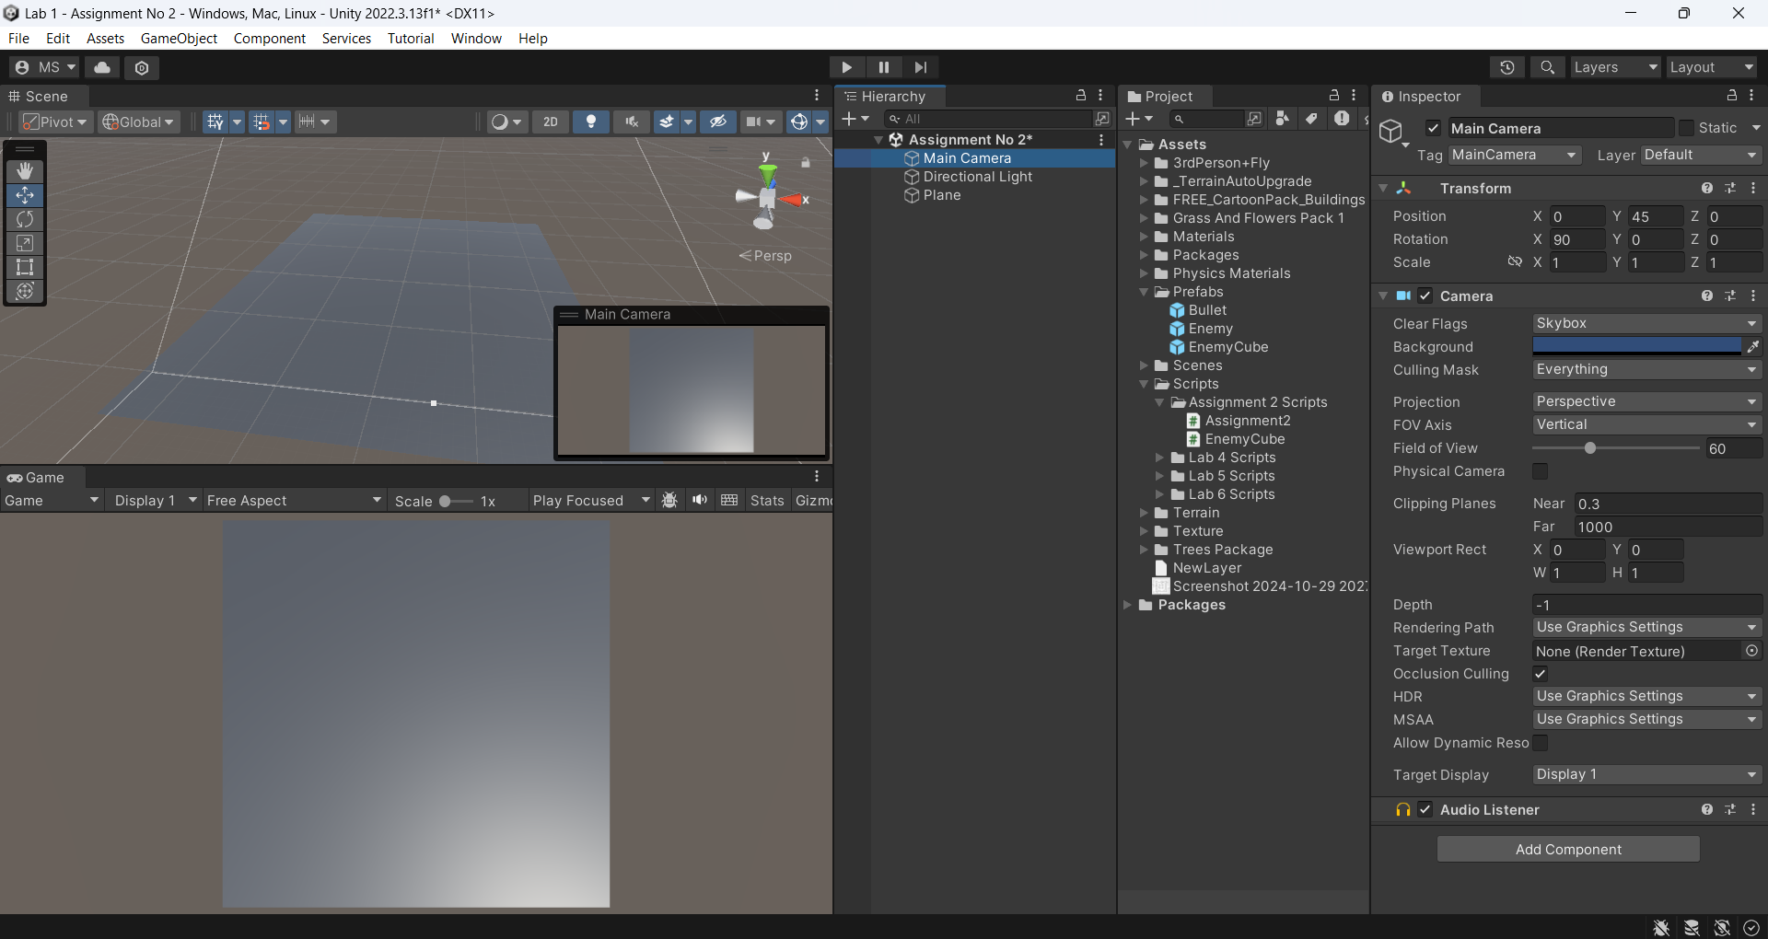

**Step 2:** I made a script to instantiate enemy cubes on the plane on random location by pressing Space.

**Step 3:** Applied script on the Plane and then mapped the enemy Cube prefab to the enemy Cube object in the inspector

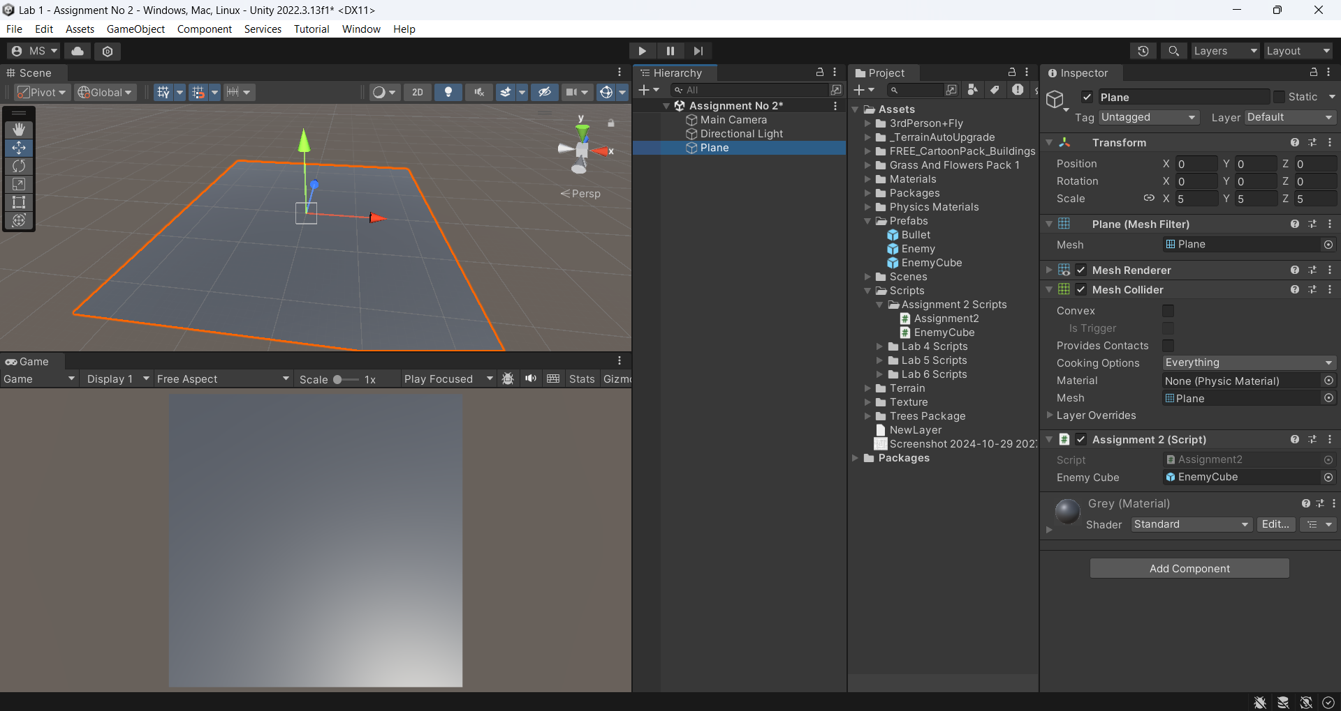

using System.Collections;

using System.Collections.Generic;

using UnityEngine;

public class Assignment2 : MonoBehaviour

{

[SerializeField]

private GameObject enemyCube;

float centerToEdge = 24f;

// Update is called once per frame

void Update()

{

if (Input.GetKeyDown(KeyCode.Space))

{

Vector3 randomLocationOnPlane = new Vector3(Random.Range(-centerToEdge, centerToEdge), 1, Random.Range(-centerToEdge, centerToEdge));

Instantiate(enemyCube, randomLocationOnPlane,Quaternion.identity);

}

}

}

**Step 4:** I also made a script to destroy enemy cube after two seconds and applied it on the enemy cube prefab.

using System.Collections;

using System.Collections.Generic;

using UnityEngine;

public class EnemyCube : MonoBehaviour

{

private void Start()

{

Destroy(gameObject,2);

}

}

**Step 5:** I play the scene and pressed space to spawn few Game objects in the scene. Each cube destroyed after two seconds from its spawning time.

